3.Steps to signup in Github:

GitHub is a version management and collaboration tool for programming. It allows you and others to collaborate on projects from any location. This course covers the fundamentals of GitHub, such as repositories, branches, commits, and pull requests.is a platform where software developers, QA, tech comms work together. To work on this platform we need account/login credentials to view projects, code deploying status, identify bugs.

Open browser, go to the website github.com, click signup, create user id and password.



1. Type your email id and click continue 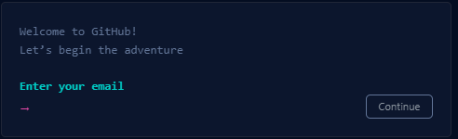

2. Type the password and create an account, click continue

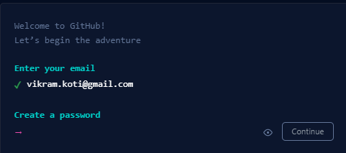

3. Create your username and click continue (Username should contain alphanumeric characters

or single hyphens, and cannot begin or end with a hyphen per guidelines).

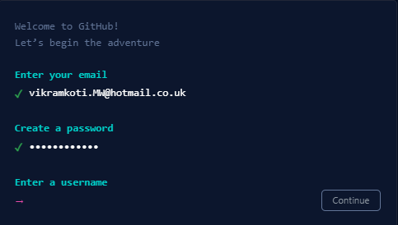

4. You will be asking to receive updates via email, type Yes or no with the letters of Y or N

and click continue

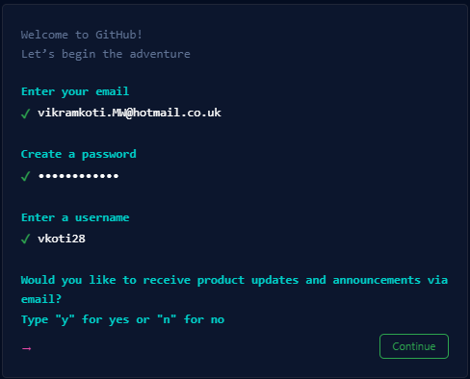

5. As part of the verification process, you will ask to start the puzzle option to confirm

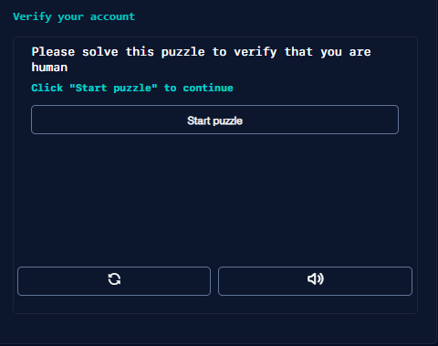

6. Select an appropriate option to validate and you will receive the code to mention the email id

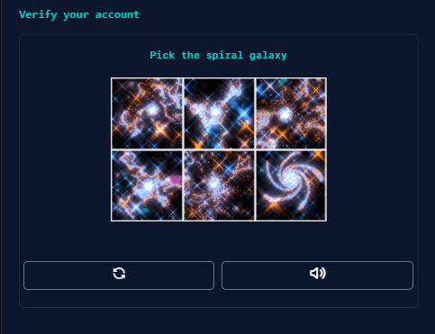

6. Enter the code and validate the signup process, if you did not receive the code,

click resent the code or update your email id

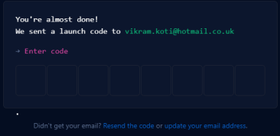

7. Complete the signup process, you will be direct to the welcome page and inquire

about your team size, student or teacher.

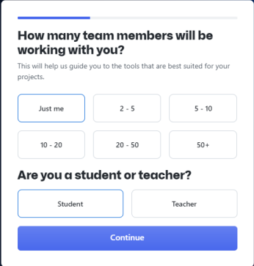

8. You will be directed to the next page which is the specific features are you interesting

such as collabarating coding, automation and CI/CD and Security.

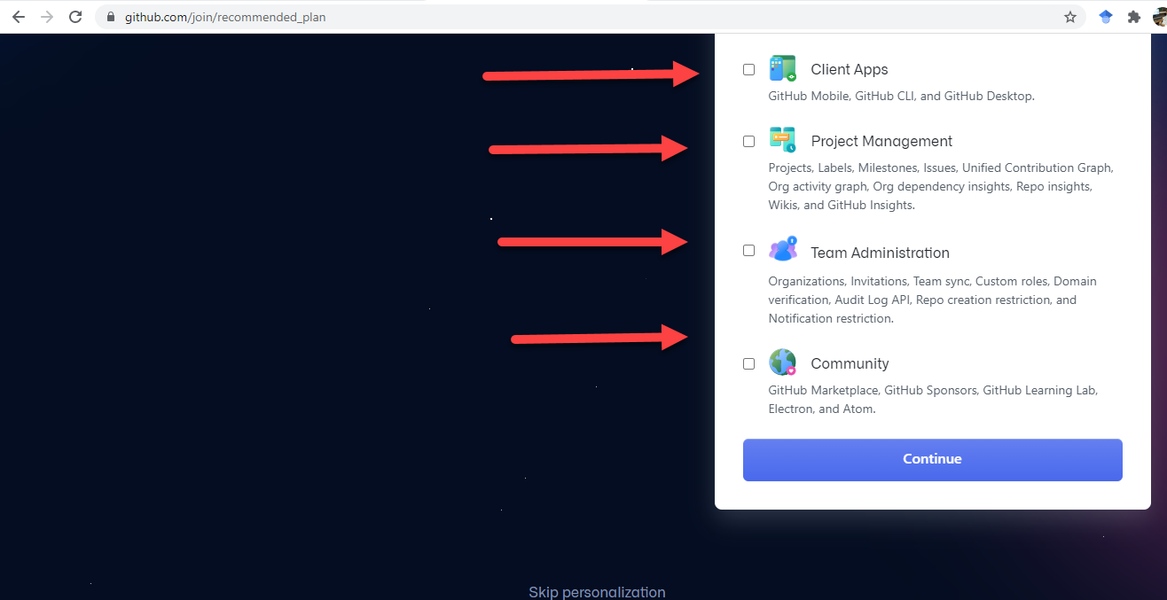

3.5: It takes us to the next page to select the various subscription options available at the Github website. Select your subscription plan according to your choice and join for your frequent use. ( See below image).

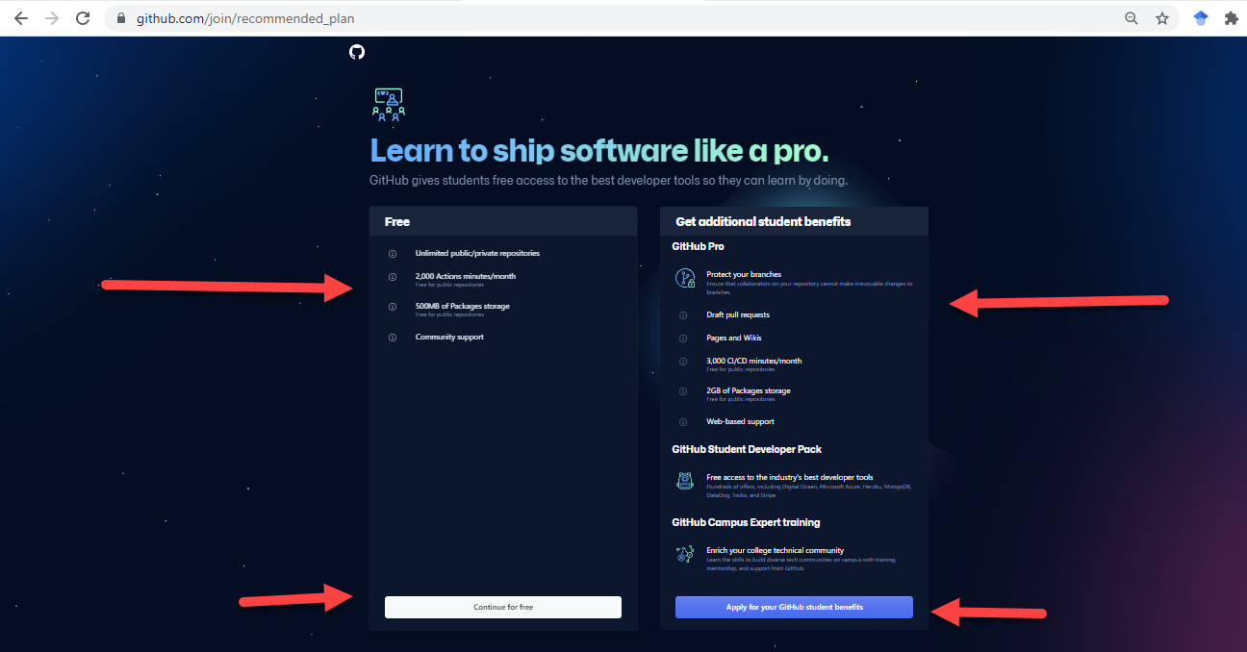

3.6: Based on the option selected by the GitHub portal to allocate the respective account, page allot to the concerned account holder. Based on schedules you subscribe to repositories, referring to the guides(See Image).

